EXPERIMENT 7

DQL COMMANDS (COLLEGE SCHEMA)

Aim:

* Display student id and marks from the student table.
* Display faculty id and name from the faculty table.
* Display who got grade A.
* Display whose marks are less than 50.
* Display the students whose marks are between 50 to 60.
* Delete the failed students.
* Display activity id and name using object.
* Display student id, faculty id using course name condition with object.
* Select department name starting from ‘d’ and faculty name ending with ‘ ’.
* Select activity having characters between ‘ck’.
* Group by faculty id and display.
* Display the students list whose grade is A using having.
* Display the faculty list who are teaching PPS.
* Apply aggregate functions in student marks - max, min, sum, count, avg.

**Procedure:**

**Code:**

* **select studid, subject, marks from student;**

**Output:**

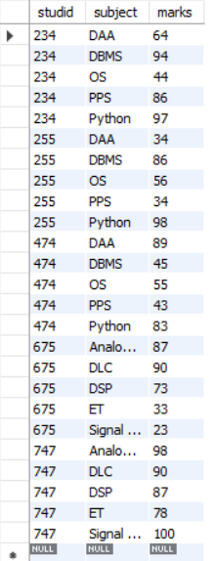

**Code:**

* **select fac_id, fac_name from faculty;**

**Output:**

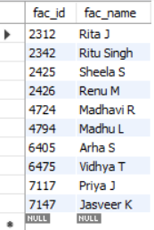

**Code:**

* **select studid, stdname, subject from student where grade = "A";**

**Output:**

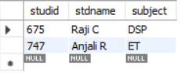

**Code:**

* **select studid, stdname, subject, marks from student where marks < 50;**

**Output:**

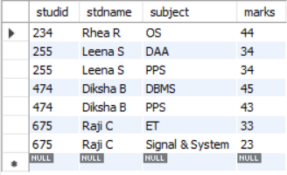

**Code:**

* **select studid, stdname, subject, marks from student where marks > 50 and marks < 60;**

**Output:**

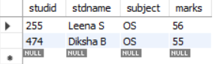

**Code:**

* **delete from student where studid in (select * from (select studid from student where grade = "F") temp);**
* **select * from student;**

**Output:**

* **Records of Raji C are deleted from student table**

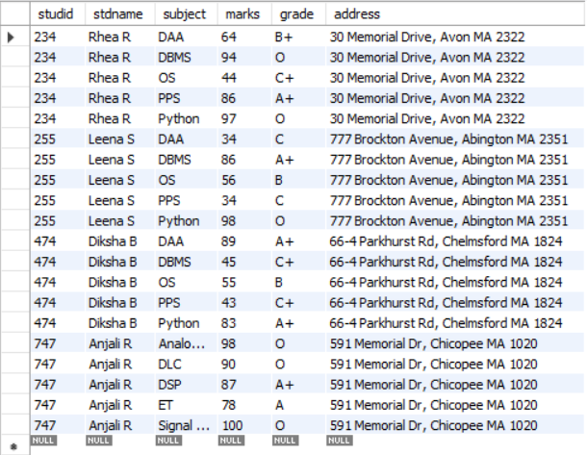

**Code:**

* **select a.act_id, a.act_name from activity a;**

**Output:**

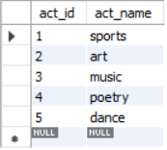

**Code:**

* **SELECT s.studid, f.fac_id from student s, faculty f where s.subject = f.course;**

**Output:**

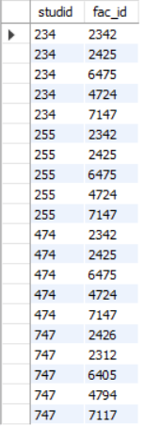

**Code:**

* **SELECT * from faculty where course LIKE 'd%' and fac_name LIKE '%S';**

**Output:**

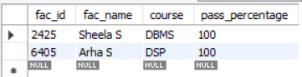

**Code:**

* **SELECT * from activity where act_name BETWEEN 'c%' AND 'k%';**

**Output:**

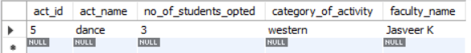

**Code:**

* **SELECT fac_id from faculty group by fac_id;**

**Output:**

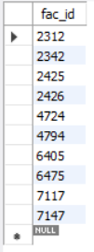

**Code:**

* **SELECT stdname, grade FROM student where grade IN (SELECT grade from student group by grade having grade = 'A');**

**Output:**



**Code:**

* **SELECT * from faculty where course = 'PPS';**

**Output:**

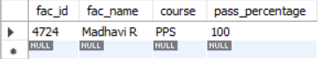

**Code:**

* **SELECT stdname, marks, subject from student where marks in (SELECT min(marks) from student);**
* **SELECT stdname, marks, subject from student where marks in (SELECT max(marks) from student);**
* **SELECT stdname, sum(marks) from student group by stdname;**
* **SELECT subject, ROUND(avg(marks), 2) as "subject average" from student group by subject;**
* **SELECT grade, count(grade) as "No. of students" from student group by grade order by marks DESC;**

**Output:**

